Project Name : Resort Villa |  |  |  |  | Area：24.00m²
Size: 4m×6m×3m
Ite | No. | Item | Size | Qty. | Reference Photo
Main
 | 1 | Door frame | Steel tube □80
 | 2 | Outside wall | 8mm cement board |  | 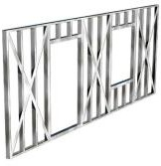  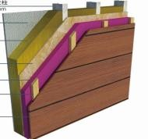
 | 3 |  | waterproof and breathable membrane
 | 4 |  | 9mm OSB board（1220×2440）
 | 5 |  | C89×0.75 Zinc aluminized keel
 | 6 |  | glass wool insulation
 | 7 |  | 8mm calcium silicate board
 | 8 |  | 6mm calcium silicate board
 | 9 | Inside wall | 6mm calcium silicate board |  | 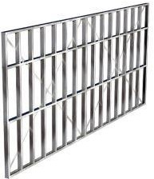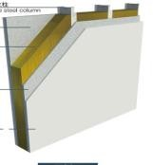
 | 10 |  | 8mm calcium silicate board
 | 11 |  | glass wool insulation
 | 12 |  | C89×0.75 Zinc aluminized keel
 | 13 |  | 8mm calcium silicate board
 | 14 |  | 6mm calcium silicate board
 | 15 | Roof  Ceiling | C89×0.75 Zinc aluminized keel |  | 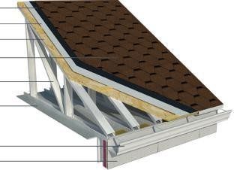
 | 16 |  | 9mm OSB board（1220×2440）
 | 17 |  | glass wool insulation
 | 18 |  | 6mm calcium silicate board
 | 19 |  | C89×0.75 Zinc aluminized keel
 | 20 |  | 6mm calcium silicate board
 | 21 | Door | Single open wooden door |  | 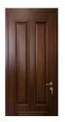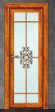
 | 22 |  | Aluminium alloy glass toilet door
 | 23 |  | Aluminium alloy double glass sliding door

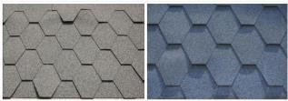
6.70

Project Name : Resort Villa
Size: 4m×6m×3m |  |  |  | Area：24.00m²
Ite | No. | Item | Size | Qty. | Reference Photo
 | 24 | Window | Aluminum alloy fixed glass window |  | 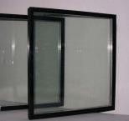
 | 25 |  | Aluminum alloy top-hung glass window |  | 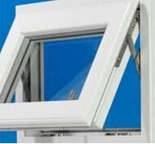
 | 26 | Covering | Galvanized steel sheet
 | 27 | Roof gutter | Aluminum alloy gutter, Aluminum alloy downing pipe |  | 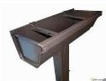
 | 28 | Hardware | Self-tapping Screw, Rivet, Bolt, etc.
 | 29 | Sel | Sel glue
Outside decoration
 | 1 | Outside wall decoration | WPC cladding |  | 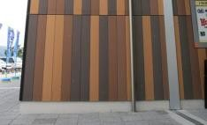
 | 2 |  | aluminum-plastic panel
 | 3 | Roof decoration | asphalt tile
 | 4 |  | Water-proof material
Inside decoration
 | 1 | Inside wall decoration | Wall puttying |  | 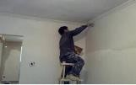
 | 2 | Wall tile | Wall tile |  | 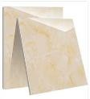
 | 3 |  | Tile glue
 | 4 |  | Water-proof painting
 | 5 | Flooring | Composited wooden flooring |  | 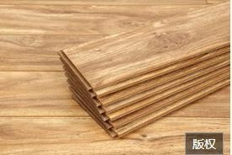
 | 6 |  | Ceramic tile
 | 7 |  | Tile glue
 | 8 |  | Water-proof painting

Project Name : Resort Villa
Size: 4m×6m×3m |  |  |  | Area：24.00m² |  | Date：2020-03-21
Ite | No. | Item | Size | Qty. |  | Reference Photo
 | 9 | Ceiling | Puttying
 | 10 |  | Aluminum alloy ceiling for bathroom |  |  | 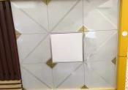
 | 11 | Sitting toilet
 | 12 | Washing basin
 | 13 | Shower room | with shower head
 | 14 | Kitchen basin | with faucet
 | 15 | Kitchen cabinet | quartz
Total
Total | 1 | Total (EXW price) | 24.00 ㎡ |  | US$ 17,000.00
 | 2 | FOB cost | One 40'HQ can load 2 units |  | US$ 980.00
 | 3 | Total (FOB to Shenzhen port) |  |  | US$ 17,980.00
Remarks：
1、The quotation is not including fireproof coating, expenses for surveying on steel structure, customs declaration cost, commodity inspection and etc.
2、 Due to the price of steel materials is unstable, the quotation valid in 7 days.
